**-- Case Study Questions**

**-- 1)What is the total amount each customer spent at the restaurant?**

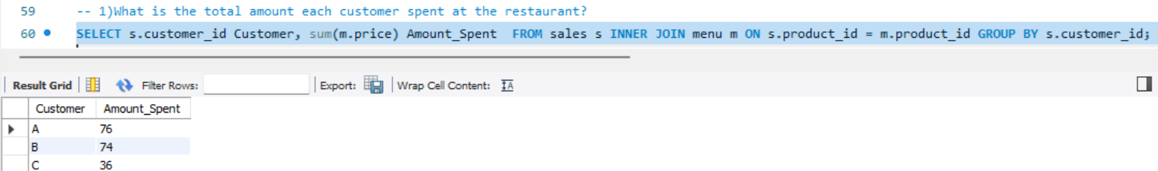

**-- 2)How many days has each customer visited the restaurant?**

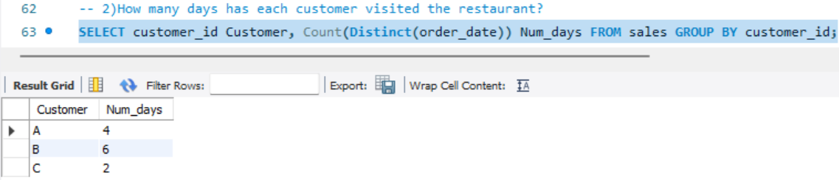

**-- 3)What was the first item from the menu purchased by each customer?**

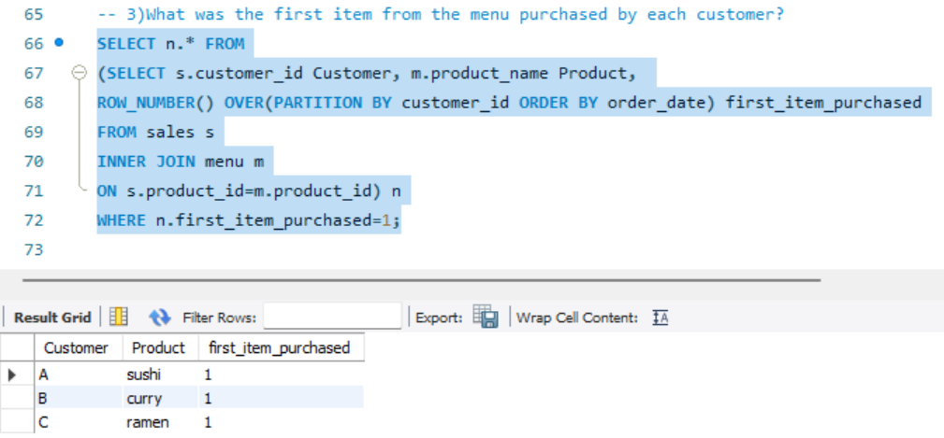

**-- 4)What is the most purchased item on the menu and how many times was it purchased by all customers?**

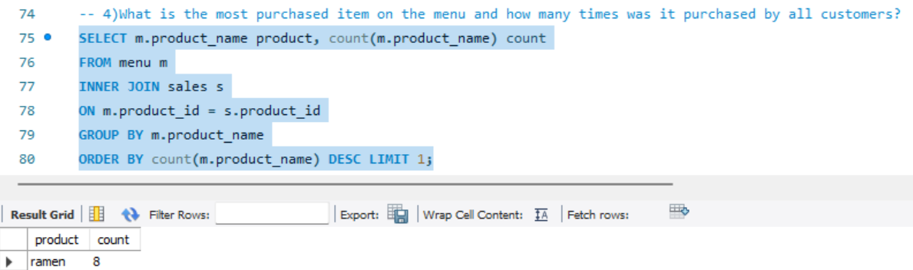

**-- 5)Which item was the most popular for each customer?**

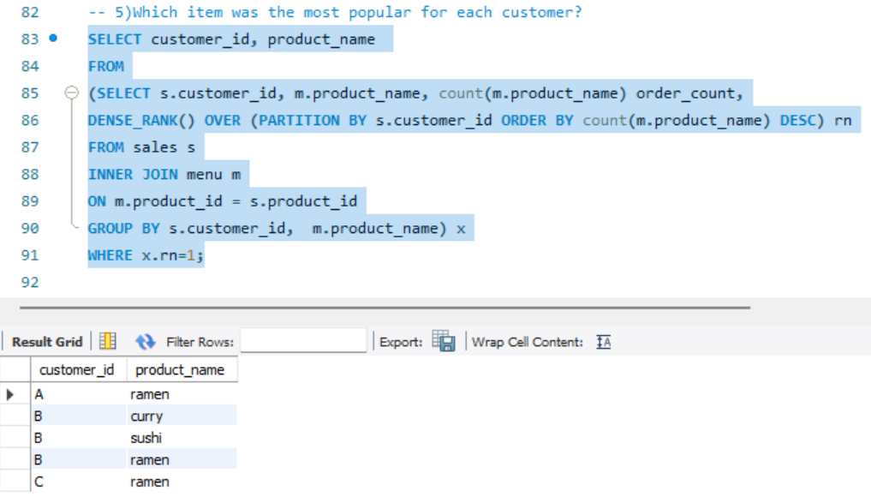

**-- 6)Which item was purchased first by the customer after they became a member?**

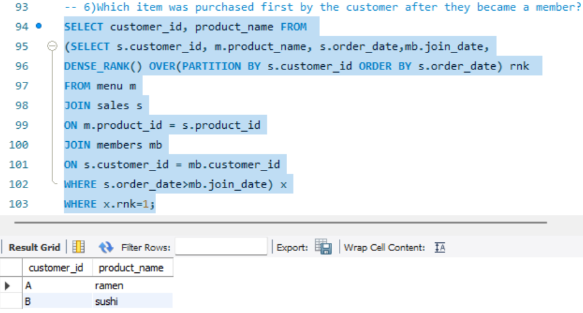

**-- 7)Which item was purchased just before the customer became a member?**

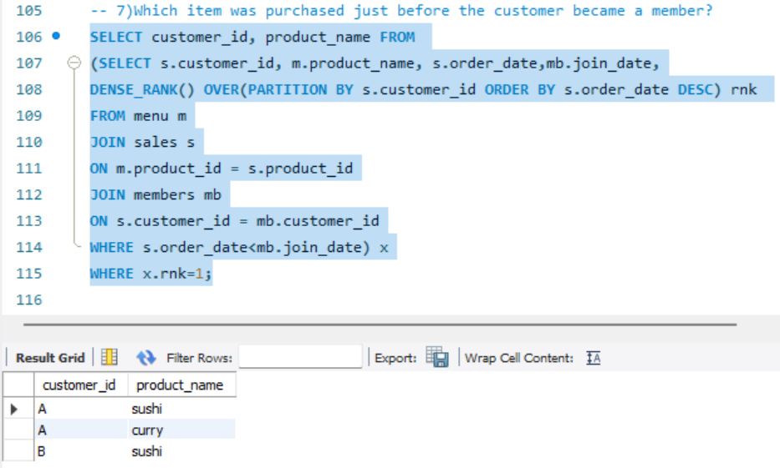

**-- 8)What is the total items and amount spent for each member before they became a member?**

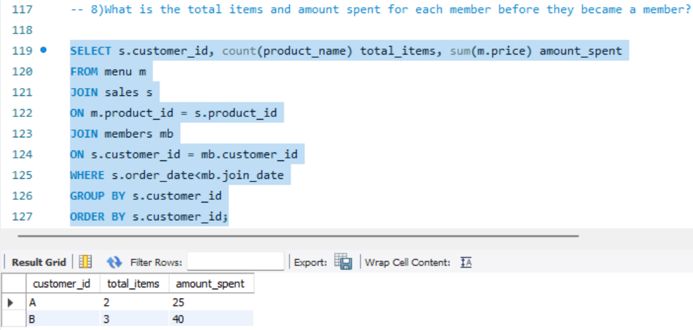

**-- 9)If each $1 spent equates to 10 points and sushi has a 2x points multiplier - how many points**

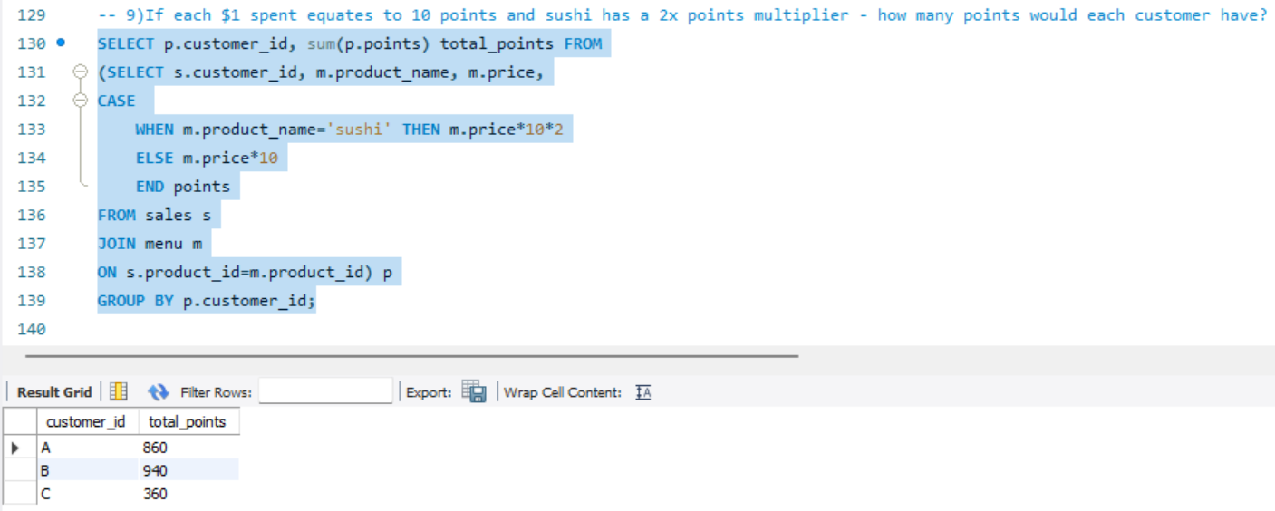

**-- 10)In the first week after a customer joins the program (including their join date) they earn 2x points on all items, not just sushi - how many points do customer A and B have at the end of January?**

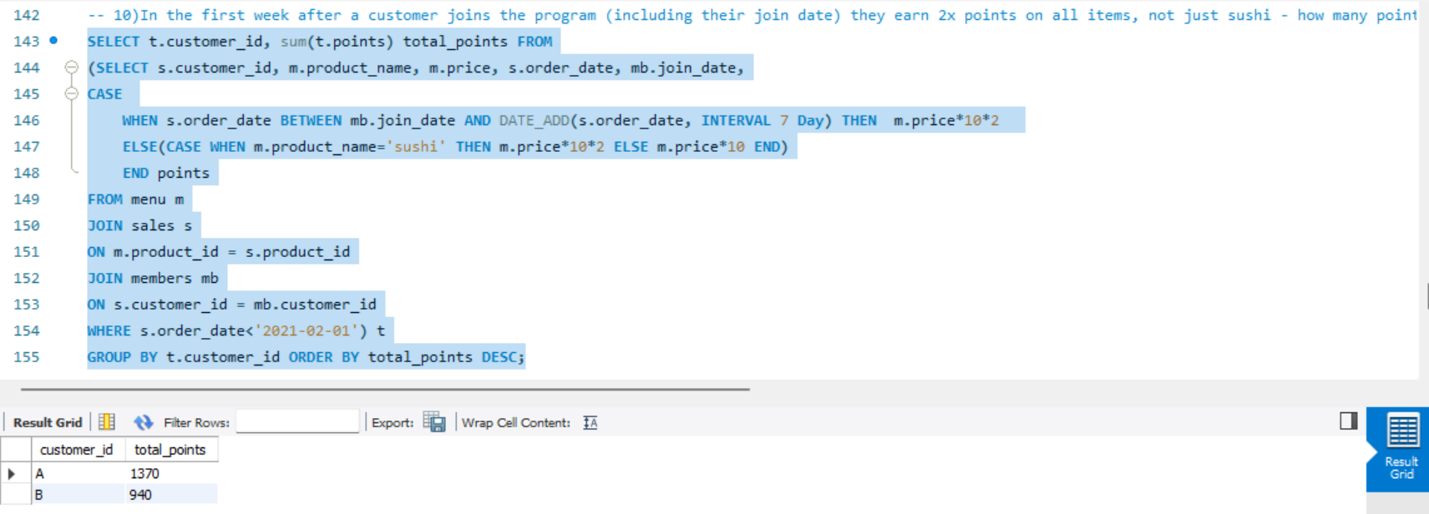

**-- 11) Determine the name and price of the product ordered by each customer on all order dates and find out whether the customers was a member on order date?**

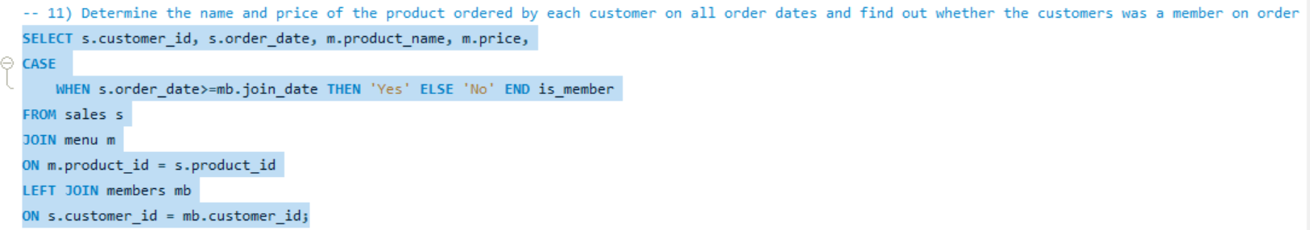

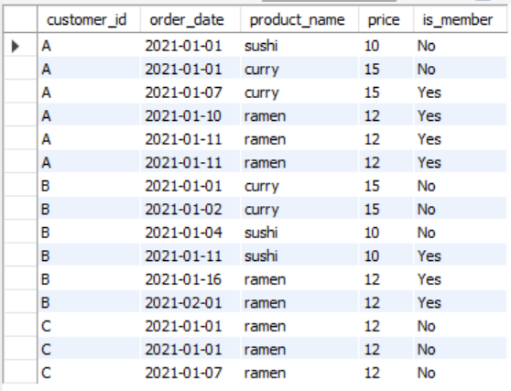

**-- 12) Rank the previous output based on the order_date for each customer. Display NULL if customer was not a member when a dish was ordered.**

